**Target - Business Case SOLUTION**

**Q - What does ‘good’ look like?**

1. **Import the dataset and do usual exploratory analysis steps like checking the structure & characteristics of the dataset:**
   1. **Data type of all columns in the “customers” table.**

**ANS A**- SELECT COLUMN_NAME, DATA_TYPE

FROM target-406519.Target.INFORMATION_SCHEMA.COLUMNS

WHERE table_name = 'customers'

**SCREENSHOT**

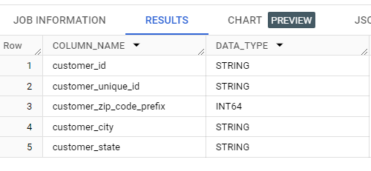

**INSIGHTS** - As per result, it is concluded that most of data are store in the form of string (varchar) except customer _zip_code_prefix**.**

* 1. **Get the time range between which the orders were placed.**

**ANS B**- SELECT

min(order_purchase_timestamp) as first_order,

max(order_purchase_timestamp) as last_order

FROM `Target.orders`

**Screenshot-**

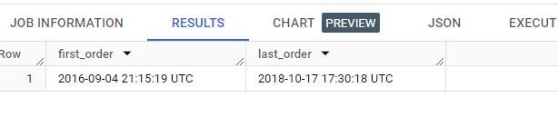

**INSIGHTS** – This help to understand product timeline in market. This help in time range of product and it popularity, order pattern.

* 1. **Count the Cities & States of customers who ordered during the given period.**

**UNIQUE VALUE - USE KEYWORD DISTINCT**

ANS C - SELECT

COUNT(DISTINCT geolocation_city) AS unique cities,

COUNT(DISTINCT geolocation_state) AS unique tates

FROM `Target.geolocation`

**Screenshot-**

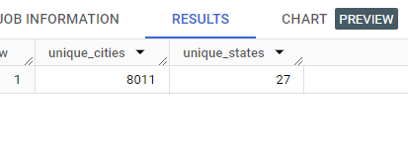

**ANS - repeated orders from CITIES and STATES**

SELECT

COUNT( geolocation_city) AS number_of_cities,

COUNT( geolocation_state) AS number_of_states

FROM `Target.geolocation`

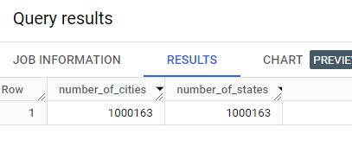

**INSIGHTS** – This help in knowing the product popularity among the no of cities and in states. This two results gave us the unique value and repeated orders of the products.

1. **In-depth Exploration:**
   1. Is there a growing trend in the no. of orders placed over the past years?

ANS -

SELECT EXTRACT(YEAR FROM order_purchase_timestamp) AS year,

COUNT(*) AS number_of_orders

FROM `Target.orders`

GROUP BY 1

ORDER BY 1;

Screenshot

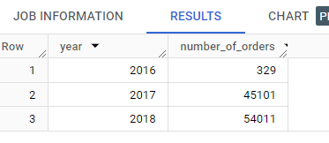

**Insights** – In the first year of product launch, there was a few sales and growth jumps to five times. We observe the pattern increase over a span of year.

* 1. Can we see some kind of monthly seasonality in terms of the no. of orders being placed?

ANS B -

WITH cte AS

(

SELECT

*,

EXTRACT ( DATE FROM order_purchase_timestamp) AS order_date,

EXTRACT ( YEAR FROM order_purchase_timestamp) AS order_year,

 EXTRACT ( MONTH FROM order_purchase_timestamp) AS order_month,

FROM `target-406519.Target.orders`

)

SELECT

 order_month,

 order_year,

_id) AS total_orders

FROM cte

GROUP BY

  order_month,

 order_year

ORDER BY

 order_year,

 order_month

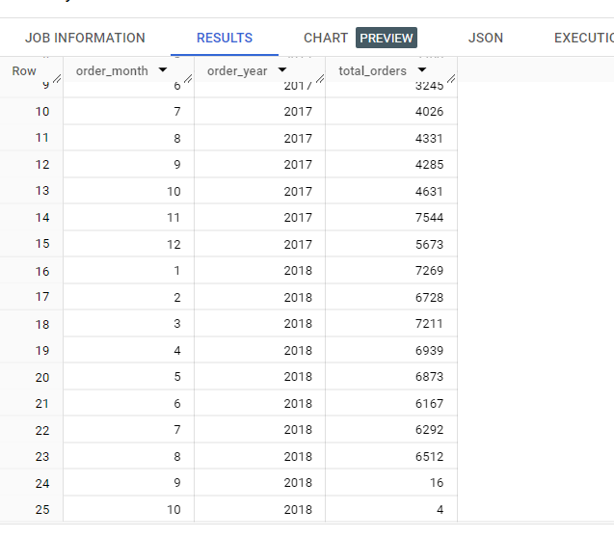

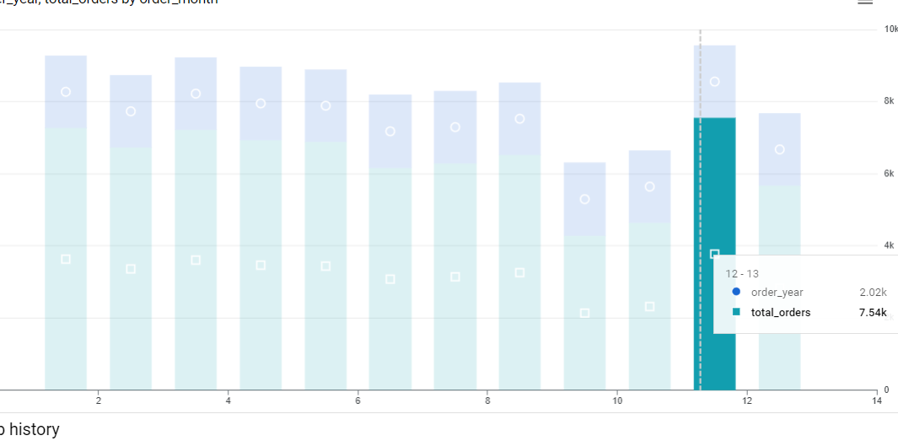

**Insights** – Seasonal effect were observe sales were increase on black Friday and New Year in Jan month. Understanding the sales behaviour and consumer activity help business to boost revenue on particular season by managing inventory of the products and also in planning discount ahead of time.

* 1. During what time of the day, do the Brazilian customers mostly place their orders? (Dawn, Morning, Afternoon or Night)
* 0-6 hrs : Dawn
* 7-12 hrs : Mornings
* 13-18 hrs : Afternoon
* 19-23 hrs : Night

SELECT

  CASE

        WHEN EXTRACT(HOUR FROM order_purchase_timestamp) BETWEEN 0

        AND 6 THEN 'Dawn'

        WHEN EXTRACT(HOUR FROM order_purchase_timestamp) BETWEEN 7

        AND 12 THEN 'Morning'

        WHEN EXTRACT(HOUR FROM order_purchase_timestamp) BETWEEN 13

        AND 18 THEN 'Afternoon'

        WHEN EXTRACT(HOUR FROM order_purchase_timestamp) BETWEEN 19

        AND 23 THEN 'Night'

  END AS order_time_interval,

  COUNT(*) AS order_count

FROM `target-406519.Target.orders`

GROUP BY order_time_interval

ORDER BY order_count DESC;

Screenshot

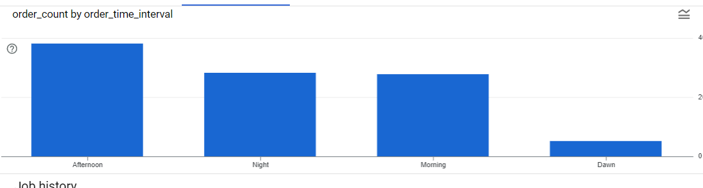

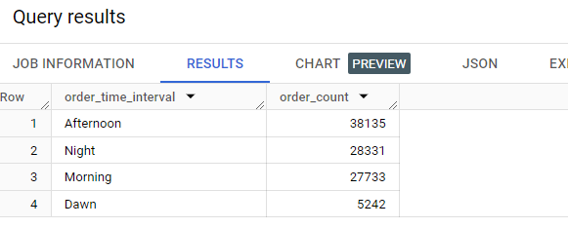

**Insights** – This brings that most of customer were active all time except Dawn time. This help the business to understand when will be product will in high demand.

1. **Evolution of E-commerce orders in the Brazil region:** 
   1. Get the month on month no. of orders placed in each state.

Solution -SELECT EXTRACT(MONTH FROM o.order_purchase_timestamp) AS

order_month, c.customer_state, COUNT(*) AS number_of_order

FROM `target-406519.Target.orders` AS o

JOIN `target-406519.Target.customers` AS c

GROUP BY order_month, c.customer_state

ORDER BY order_month, c.customer_state

ON o.customer_id = c.customer_id

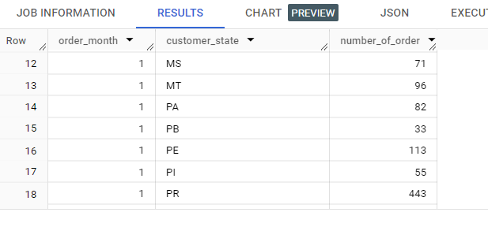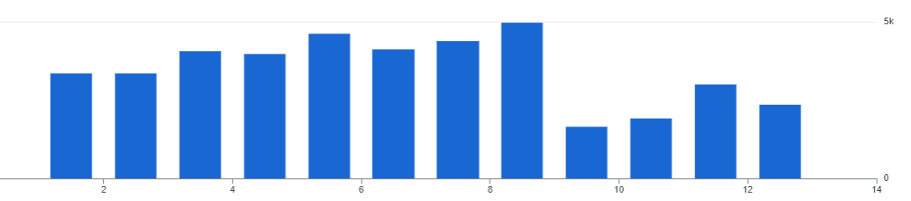

**Insights** – This help us to target the potential products on particular month to bring most revenue and also inform marking team to market to product in that area.

* 1. **How are the customers distributed across all the states?**

SELECT customer_state,

COUNT(DISTINCT customer_id) AS total_custmers

FROM `target-406519.Target.customers`

GROUP BY 1

ORDER BY 1 DESC

SCREENSHOTS

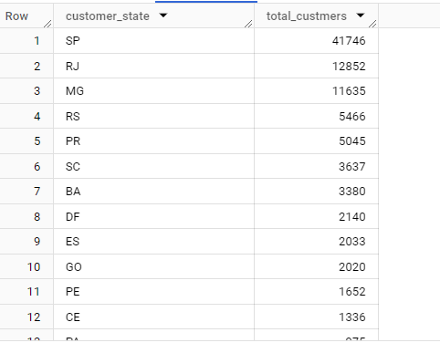

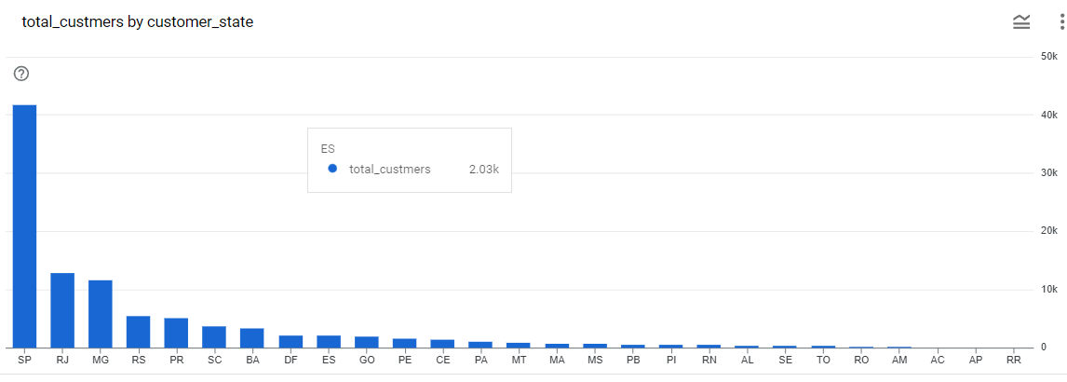

**Insights** – This show that the most wanted state having the highest demand of product. This helps production team to evaluate how much product they need in particular states.

1. **Impact on Economy: Analyze the money movement by e-commerce by looking at order prices, freight and others.**
   1. Get the % increase in the cost of orders from year 2017 to 2018 *(include months between Jan to Aug only).*

You can use the “payment_value” column in the payments table to get the cost of orders.

SELECT

ROUND((((total_payment_2018 - total_payment_2017) /

total_payment_2017) * 100), 2) AS percentage_increase

FROM (

 SELECT

 SUM(CASE

 WHEN EXTRACT(YEAR FROM o.order_purchase_timestamp) = 2017

AND EXTRACT(MONTH FROM o.order_purchase_timestamp) BETWEEN 1 AND

8 THEN p.payment_value

 ELSE 0

 END) AS total_payment_2017,

 SUM(CASE

 WHEN EXTRACT(YEAR FROM o.order_purchase_timestamp) = 2018

AND EXTRACT(MONTH FROM o.order_purchase_timestamp) BETWEEN 1 AND

8 THEN p.payment_value

 ELSE 0

 END) AS total_payment_2018

 FROM

 `target-406519.Target.payments` AS p

 JOIN`target-406519.Target.orders` AS o

 ON p.order_id = o.order_id

 );

**Screenshot**

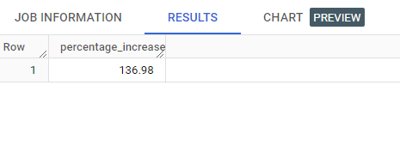

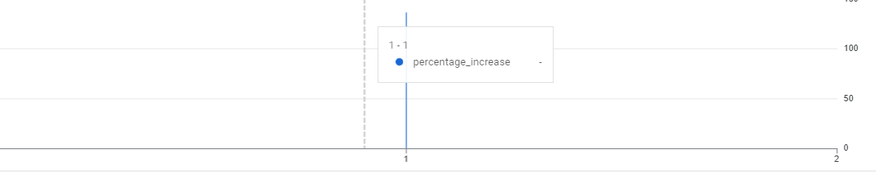

**Insights** - This query show the amount of increase of sales between orders placed from January to August are considered.

* 1. Calculate the Total & Average value of order price for each state.

SELECT customer_state,

  ROUND(SUM(p.payment_value),2) AS total_order_price,

  ROUND(AVG(p.payment_value),2) AS average_order_price

FROM `target-406519.Target.payments` AS p

JOIN `target-406519.Target.orders` AS o

ON p.order_id = o.order_id

JOIN `target-406519.Target.customers` AS c

ON o.customer_id = c.customer_id

GROUP BY 1

ORDER BY 2 DESC

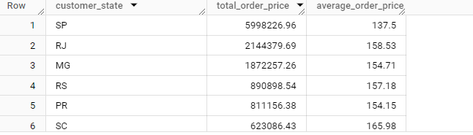

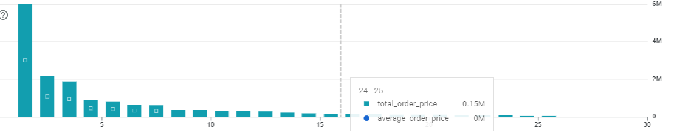

**Insights –** This query brought analyst attention on particular total_order price among states and average no of orders.

* 1. Calculate the Total & Average value of order freight for each state.

SELECT

customer_state AS state,

 ROUND(SUM(oi.freight_value),2) AS total_freight,

ROUND(AVG(oi.freight_value),2) AS average_freight

FROM `target-406519.Target.orders` AS o

JOIN `target-406519.Target.order_items` AS oi

ON o.order_id = oi.order_id

JOIN `target-406519.Target.customers` AS c

ON c.customer_id = o.customer_id

GROUP BY 1

ORDER BY 2 DESC

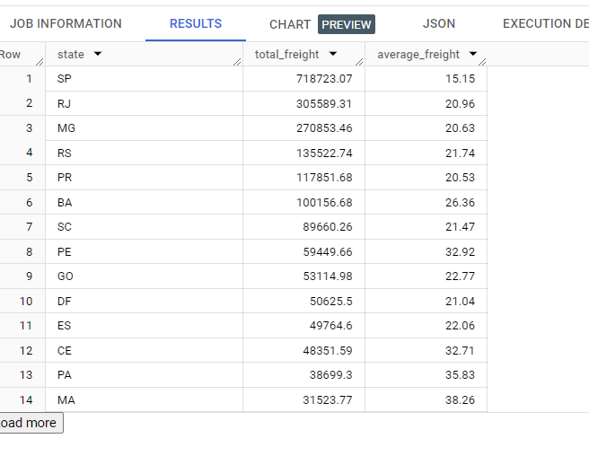

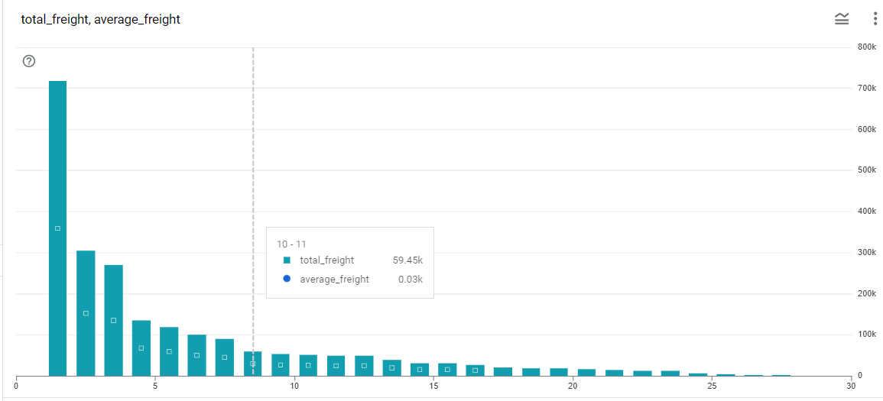

**Insights**

1. **Analysis based on sales, freight and delivery time.**
   1. Find the no. of days taken to deliver each order from the order’s purchase date as delivery time.

Also, calculate the difference (in days) between the estimated & actual delivery date of an order.

Do this in a single query.

You can calculate the delivery time and the difference between the estimated & actual delivery date using the given formula:

* **time_to_deliver** = order_delivered_customer_date - order_purchase_timestamp
* **diff_estimated_delivery** = order_estimated_delivery_date - order_delivered_customer_date

SELECT

order_id,

DATE_DIFF(DATE(order_delivered_customer_date),

DATE(order_purchase_timestamp), DAY) AS delivery_time,

DATE_DIFF(DATE(order_estimated_delivery_date),

DATE(order_delivered_customer_date), DAY) AS

diff_estimated_delivery

FROM `target-406519.Target.orders`

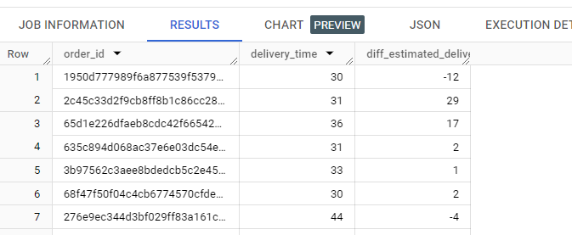

**Insights -**

* 1. Find out the top 5 states with the highest & lowest average freight value.

SELECT

 high.customer_state AS high_state,

high.average_freight_value AS high_avg_freight,

low.customer_state AS low_state,

 low.average_freight_value AS low_avg_freight

FROM

(

SELECT

c.customer_state,

 ROUND(AVG(p.freight_value),2) AS average_freight_value,

ROW_NUMBER() OVER(ORDER BY

(ROUND(AVG(p.freight_value),2))DESC) AS rowval1

 FROM `target-406519.Target.orders`   AS o

JOIN `target-406519.Target.order_items` AS p

ON o.order_id = p.order_id

JOIN `target-406519.Target.customers`  AS c

 ON o.customer_id = c.customer_id

 GROUP BY

c.customer_state

ORDER BY

 average_freight_value DESC

 LIMIT

 5

) AS high

JOIN

(

SELECT

c.customer_state,

ROUND(AVG(p.freight_value),2) AS average_freight_value,

ROW_NUMBER() OVER(ORDER BY (ROUND(AVG(p.freight_value),2)))

AS rowval2

FROM `target-406519.Target.orders`   AS o

JOIN `target-406519.Target.order_items` AS p

 ON o.order_id = p.order_id

 JOIN `target-406519.Target.customers`   AS c

ON o.customer_id = c.customer_id

 GROUP BY

 c.customer_state

 ORDER BY

 average_freight_value

LIMIT

 5

) AS low

ON high.rowval1 = low.rowval2;

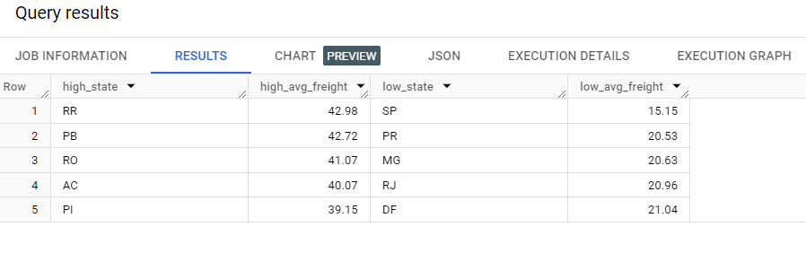

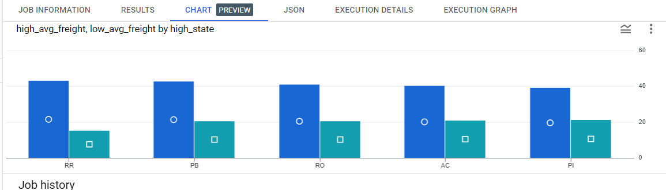

**Insights -**

* 1. Find out the top 5 states with the highest & lowest average delivery time.

WITH cte AS

(

SELECT

 c.customer_state,

 ROUND(AVG(t1.delivery_time),2) AS avg_delivery_time

FROM

 (

 SELECT

 *,

TIMESTAMP_DIFF(order_delivered_customer_date,

order_purchase_timestamp, day) AS delivery_time,

FROM

`target-406519.Target.orders`

 WHERE

 order_status = 'delivered' AND

order_delivered_customer_date IS NOT NULL

 ORDER BY

 order_purchase_timestamp

) AS t1

JOIN

`target-406519.Target.customers` AS c

ON t1.customer_id = c.customer_id

GROUP BY

 c.customer_state

ORDER BY

 avg_delivery_time

)

SELECT

c1.customer_state AS low_state,

c1.avg_delivery_time AS low_avg_delivery_time,

c2.customer_state AS high_state,

c2.avg_delivery_time AS high_avg_delivery_time

FROM

(

 SELECT

*,

ROW_NUMBER() OVER (ORDER BY cte.avg_delivery_time DESC) AS

rowval2

 FROM

 cte

ORDER BY

rowval2

) AS c2

JOIN

(

 SELECT

*,

ROW_NUMBER() OVER (ORDER BY cte.avg_delivery_time) AS

rowval1

 FROM

cte

 ORDER BY

rowval1

) AS c1

ON

c1.rowval1 = c2.rowval2

LIMIT

5;

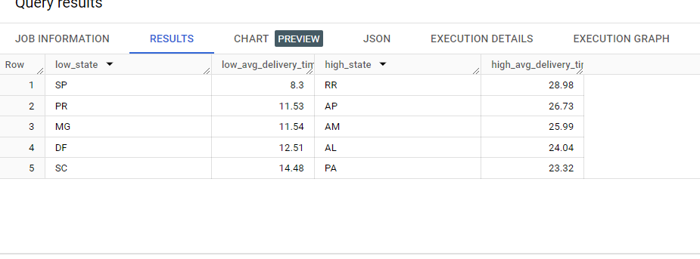

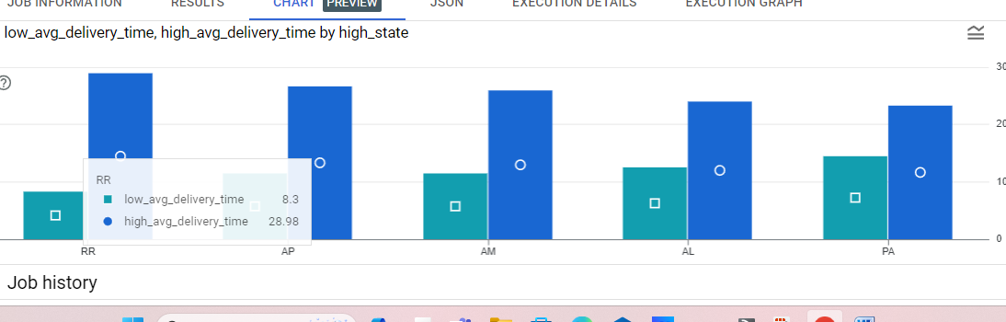

**Insights -**

* 1. Find out the top 5 states where the order delivery is really fast as compared to the estimated date of delivery.

You can use the difference between the averages of actual & estimated delivery date to figure out how fast the delivery was for each state.

 WITH delivery_speed AS (

 SELECT

 c.customer_state,

 AVG(DATE_DIFF(o.order_delivered_customer_date,

o.order_estimated_delivery_date, DAY)) AS avg_delivery_speed,

 ROW_NUMBER() OVER (ORDER BY

AVG(DATE_DIFF(o.order_delivered_customer_date,

o.order_estimated_delivery_date, DAY))) AS rank_fastest

 FROM `target-406519.Target.orders`           AS o

 JOIN `target-406519.Target.customers` AS c

 ON o.customer_id = c.customer_id

 WHERE o.order_delivered_customer_date IS NOT NULL AND

o.order_estimated_delivery_date IS NOT NULL

 GROUP BY c.customer_state

)

SELECT customer_state, avg_delivery_speed

FROM delivery_speed

WHERE rank_fastest <= 5

ORDER BY avg_delivery_speed;

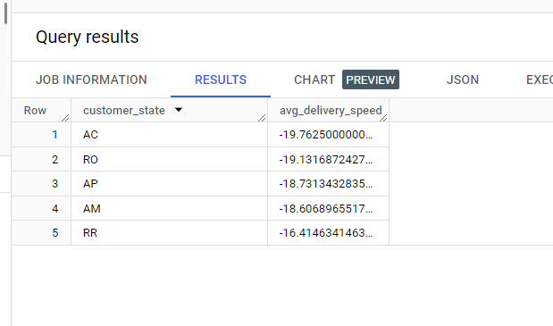

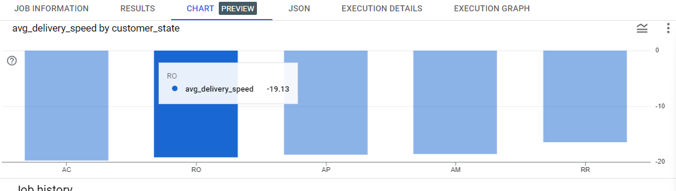

**Insights -**

1. **Analysis based on the payments:**
   1. Find the month on month no. of orders placed using different payment types**.**

SELECT

 FORMAT_TIMESTAMP('%Y-%m', o.order_purchase_timestamp) AS

month,

 p.payment_type,

COUNT(DISTINCT o.order_id) AS order_count

FROM `target-406519.Target.orders` AS o

JOIN `target-406519.Target.payments` AS p

ON o.order_id = p.order_id

GROUP BY 1, 2

ORDER BY 1

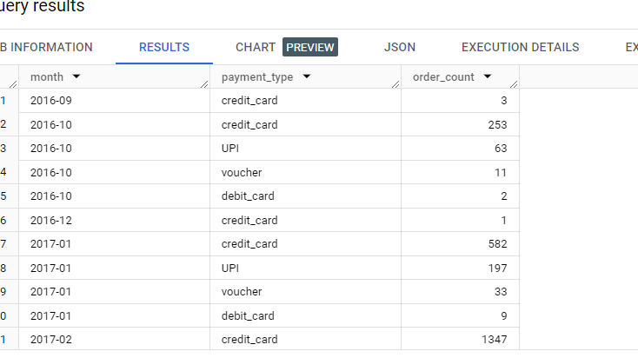

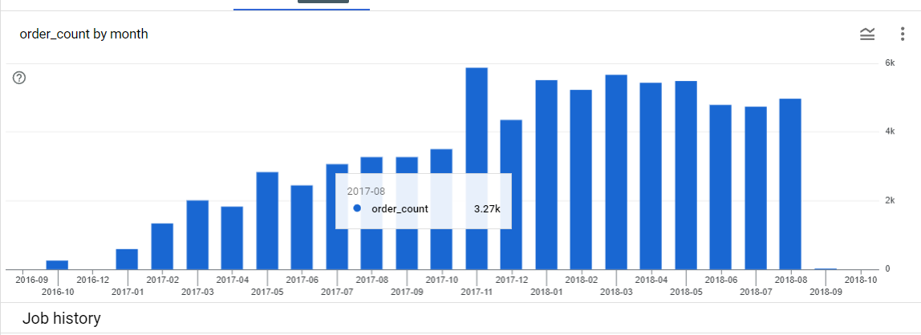

**Insights -**

* 1. **Find the no. of orders placed on the basis of the payment installments that have been paid.**

SELECT payment_installments, COUNT(DISTINCT order_id) AS order_count

FROM `target-406519.Target.payments`

GROUP BY 1

ORDER BY 1

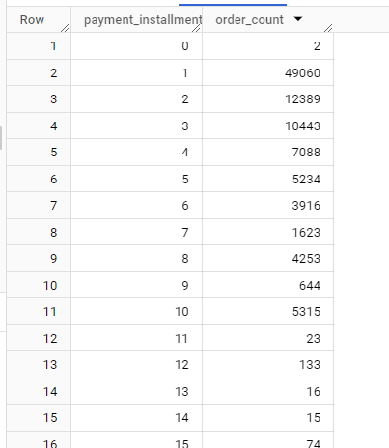

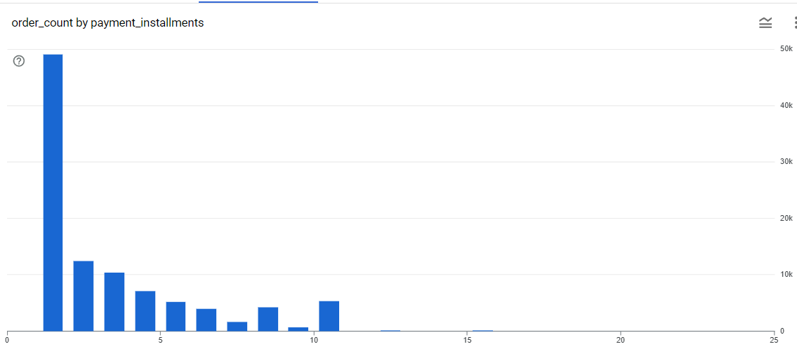

**Insights -**